**Student Assessment Submission and Declaration**

When submitting evidence for assessment, each student must sign a declaration confirming that the work is their own.

|  |  |  |  |
| --- | --- | --- | --- |
| Student name: Abdelrahman Saleh | | Assessor name:  **Somaya Alshare** | |
| Issue date (1St Submission):  **16/4/2023** | Submission date (1St Submission):  **10/6/2023** | | Submitted on: |
| In case of resubmission | | | |
| Issue date (1St Submission): | Submission date (1St Submission): | | Submitted on: |
| Programme: Higher National Diploma in computing – Software Engineering | | | |
|  | | | |
| Assignment number and title: **1. Utilising APIs to add new features to applications.** | | | |

**Level 1)**

**a) investigating API, SDK:**

**API: An API sets the rules and methods for how different software or apps can interact and share information, its like a menu at a restaurant, you don’t need to know how to cook the food, you just order it from the menu and the kitchen knows what to do on its own and will deliver a ready meal for you.**

**SDK: SDK is a toolbox that includes pre-made pieces of codes, libraries and instructions that help us create software faster and more efficiently, an SDK provides us with the building blocks and the know-how to construct something complex, like an app or a video game.**

**API-SDK relationship: As I defined API earlier I will use the same concept to describe the relationship between the two, we can think of API as a menu in a restaurant, it lists all the dishes you can order along with a description of each dish and you can order what you like and have it ready for you without concerning yourself of how it was made nor you need to know how to cook, all you have to worry about is how to order the right dish for yourself from the menu. On the other side SDK can be thought of like this, it is like we want to open our restaurant and we want to offer some of the famous dishes that other famous restaurants is serving, instead of starting from scratch and figuring out all the recipes and cooking techniques we can simply contact the other restaurant and ask them for their cooking kit, This kit would include all the recipes, ingredients and cooking instruction that we may need to make these dishes exactly as other restaurants doing it, so basically it is like we ask for a step by step documentation of how to certain tasks. So in short, we can think of the relationship between the two as asking someone to do a task for you and he will hand you the result ready (API) and as asking someone to tell you how he does this thing and do the same to reach the same result (SDK).**

**b)**

**- Access Control: We may encounter this risk if the developers are not aware of an endpoint’s existence, so they may not have implemented proper access controls or authentication mechanisms which can lead to unauthorized access and data breaches, so we must manage and regulate who can access specific resources, functions or data within an API to ensure that only authorized users or system can interact with the API to limit the risk of unauthorized access, data breaches and misuse, If not handled correctly this will have a big impact as we may face a breach of sensitive data that may affect the company’s reputation.**

**- injection Attacks: Malicious users may attempt to inject harmful code such as SQL injection or NoSQL injection through API inputs, potentially compromising the API and the system that supports it, so we must be aware of the possibility of this happening and take precautions to prevent such incidents, if an attack were to happen it will breach the database integrity and the affect may spread to the whole system and disable it.**

**- DOS attacks: an attacker can flood the API with high volume of requests, overwhelming its capacity to respond to legitimate users which will result in service disruption or unavailability, This can have big impact if it were to happen as it may stop the system from providing its services and crash it, we can prevent this by limiting a certain amount of requests for each IP address.**

**- CORS: This is not an attack as it is, it is more as a security feature that is implemented by web browsers to control requests made by web pages from one domain to resources on another domain, but this may be exploited by attackers from unauthorized cross-origin requests, I encountered this issue while developing my project as I used an API to retrieve the information of a YouTube video but it faced a problem that says that my request was banned by CORS cause I was using a private (local) domain to test my project, so people can use this to redirect requests to other sites and potentially steal users information or have access to his account or steal the session data, all of these risks are high risks that must be taking into consideration to protect our system’s data.**

**C)**

**I will take about web application API;**

**-** Authentication API (auth0): auth0 is an API that handles all authentications processes such as login, signup, logout and API access, it is as any typical API has parameters for each endpoint and documentation on how to use them and what is the limit for each endpoint.

- Payment Processing API (Stripe):

Stripe is a popular Payment Processing API used in web applications to facilitate online payments. It offers a range of features, including handling credit card transactions, managing subscriptions, and handling disputes. Stripe's API includes well-documented endpoints for creating charges, managing customers, and handling payouts. It also provides client libraries for various programming languages, making integration easier for developers.

- Social Media Integration API (Facebook Graph API):

The Facebook Graph API is a powerful tool for integrating social media features into web applications. It allows developers to access and interact with Facebook data, such as user profiles, posts, photos, and events. With this API, you can implement features like social login, sharing content on Facebook, and fetching user data. The API comes with comprehensive documentation, SDKs for multiple platforms, and robust access controls to ensure data privacy and security.

**Level Two:**

**Milestone 1)**

**1) investigating an application to add new feature to:**

Today, we can enhance apps using various APIs, and social media apps like Twitter offer exciting possibilities. One useful feature to add is 'Topic Summarization.' This helps users quickly grasp the main point of lengthy articles or complex tweets, making information digestible.

We can use OpenAI's GPT-3 or GPT-3.5 API for this. These AI models are excellent at summarizing text. By integrating this API, Twitter users can easily generate concise summaries.

The impact could be huge. Users would read faster and understand better. Twitter would become even more competitive.

Here's the URL of the company that offer this API: [OpenAI API](https://openai.com/product)."

Milestone 2)

1) i used the magazine project and added an API that retrieves a list of top movies.

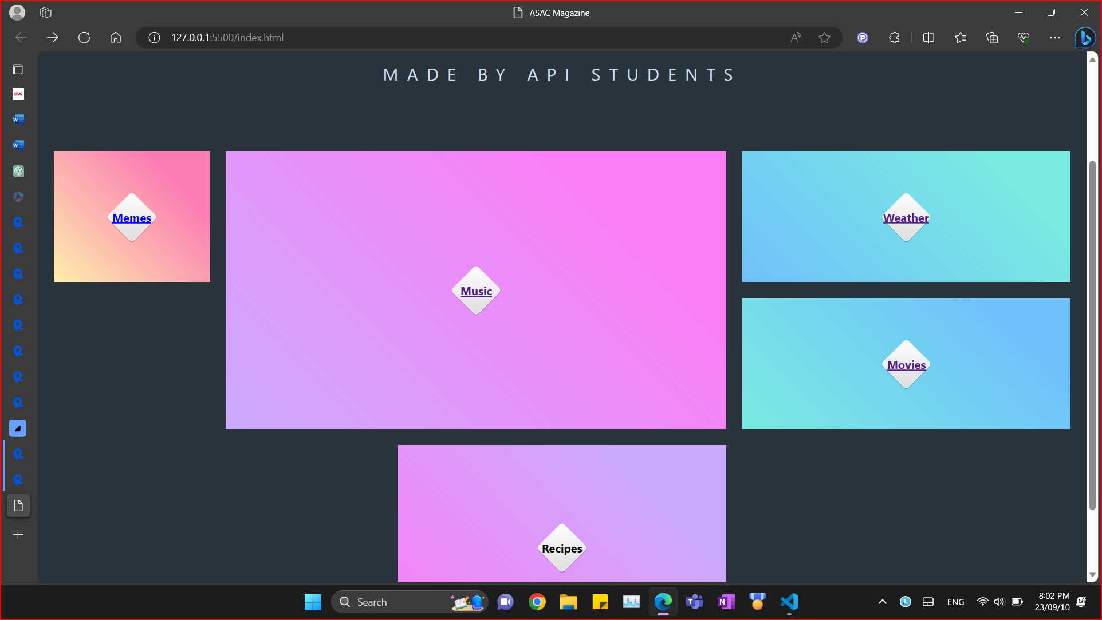

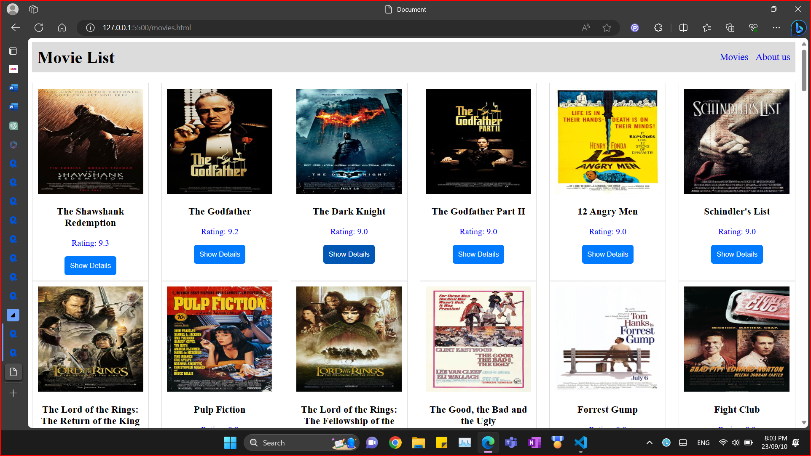

**Milestone 3)**

**1)**

**The first test that I did regarding white box testing is executing all statements except the catch and see what is the output for this, as you can see the output is a functional working website that provide services to the user.**

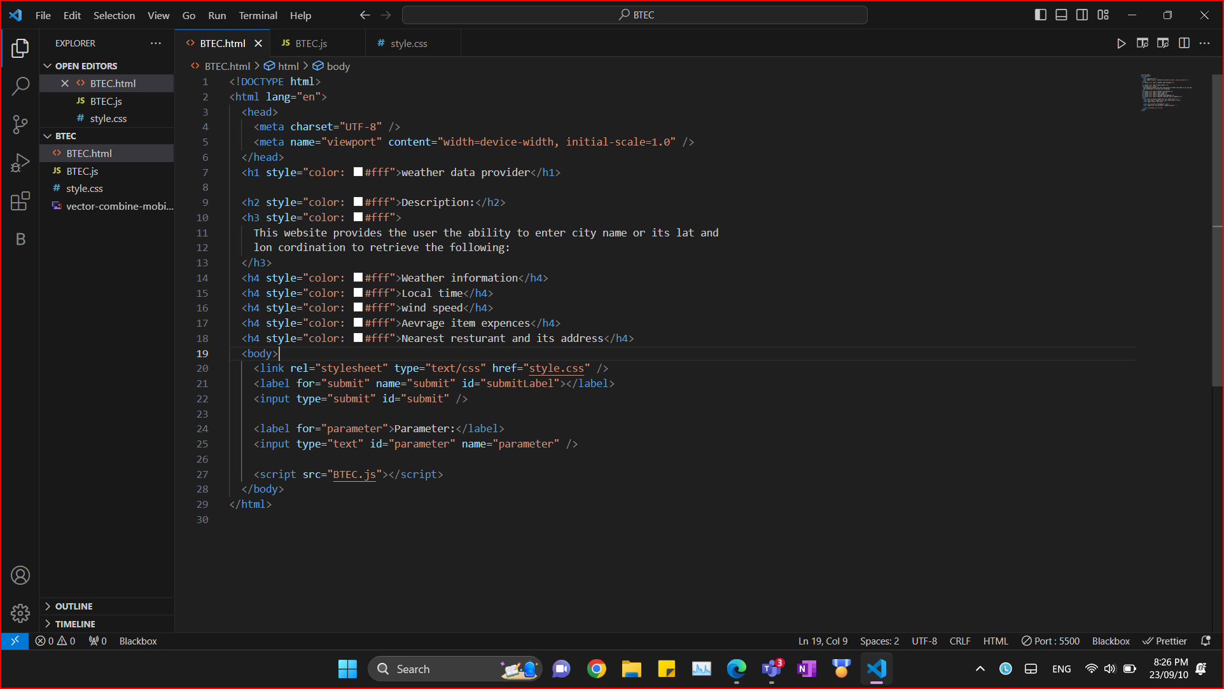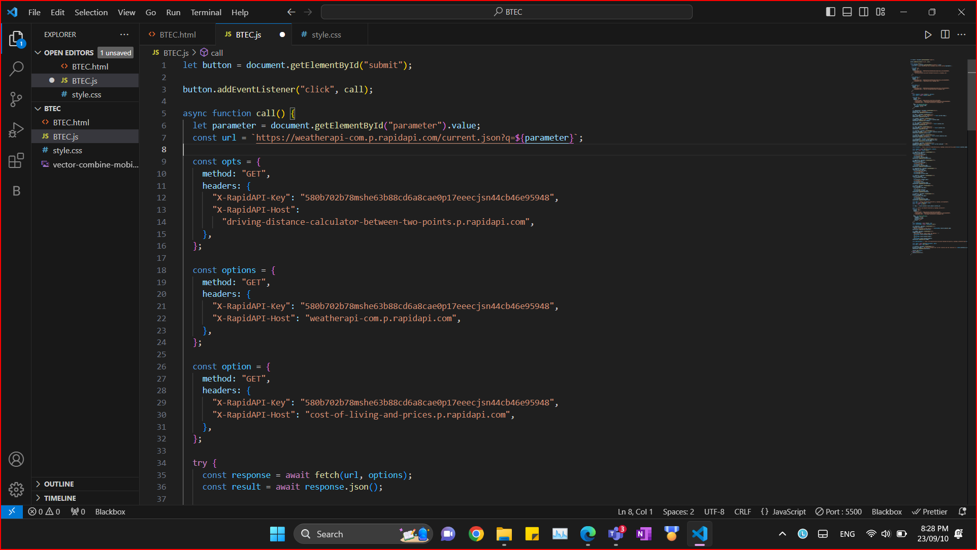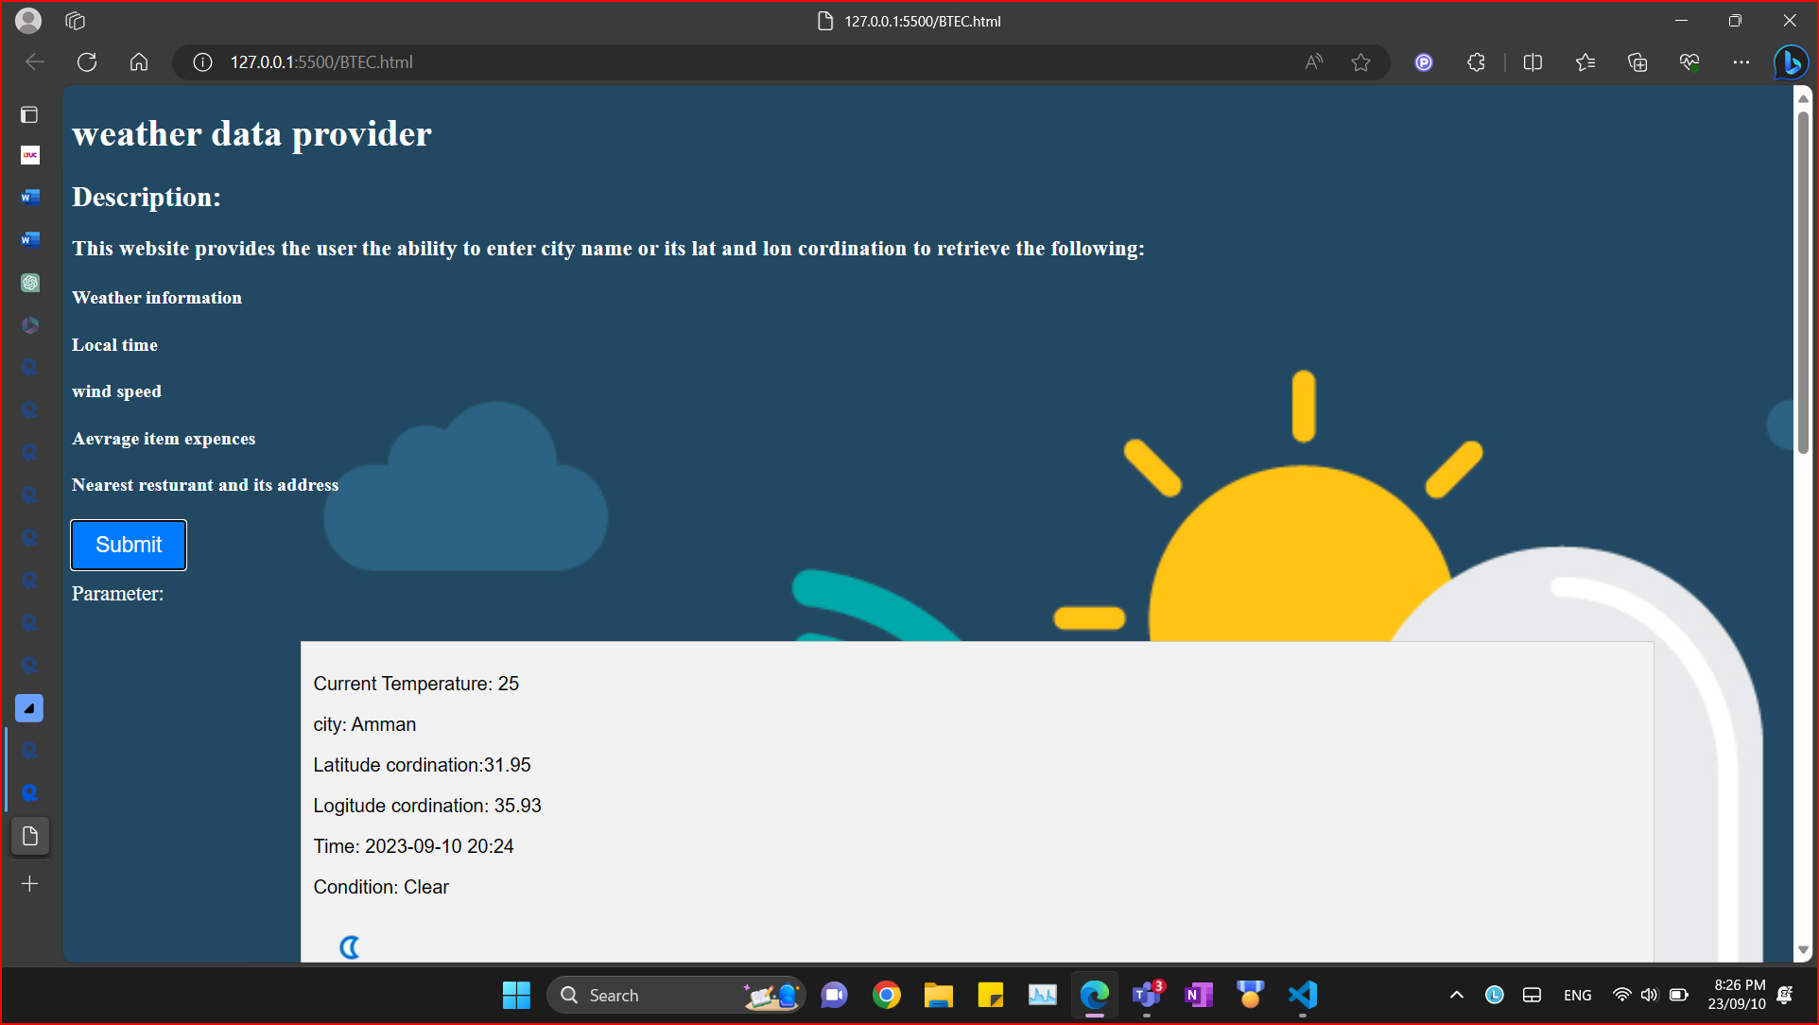

**Now for the second case of our test I deleted a part of the API key that I used and its URL to see what is the output for the catch statement.**

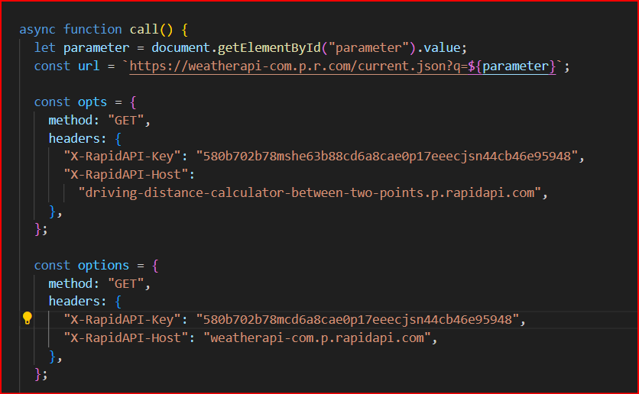

**And as you can see in the pictures below that the website does not work properly and is producing multiple errors that indicates that there is something wrong with the code.**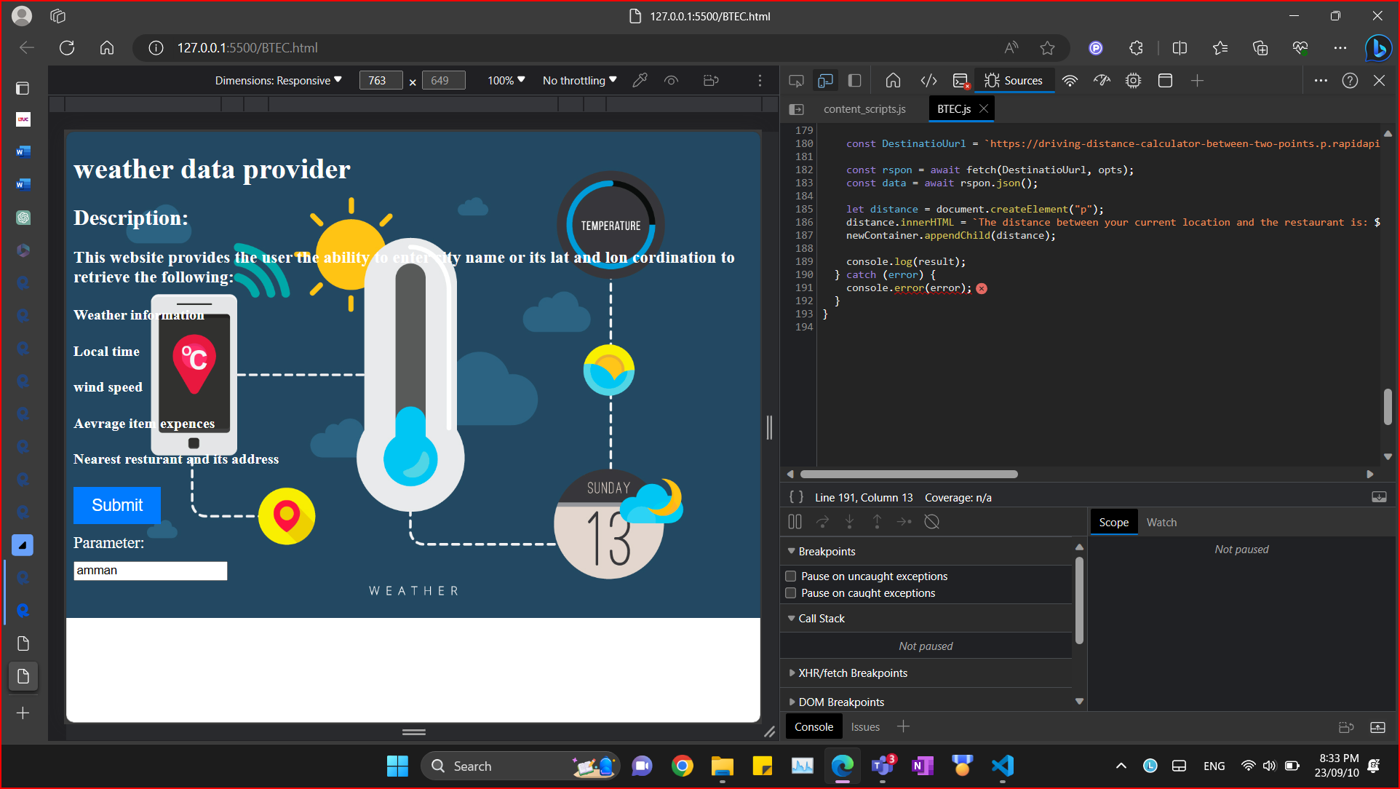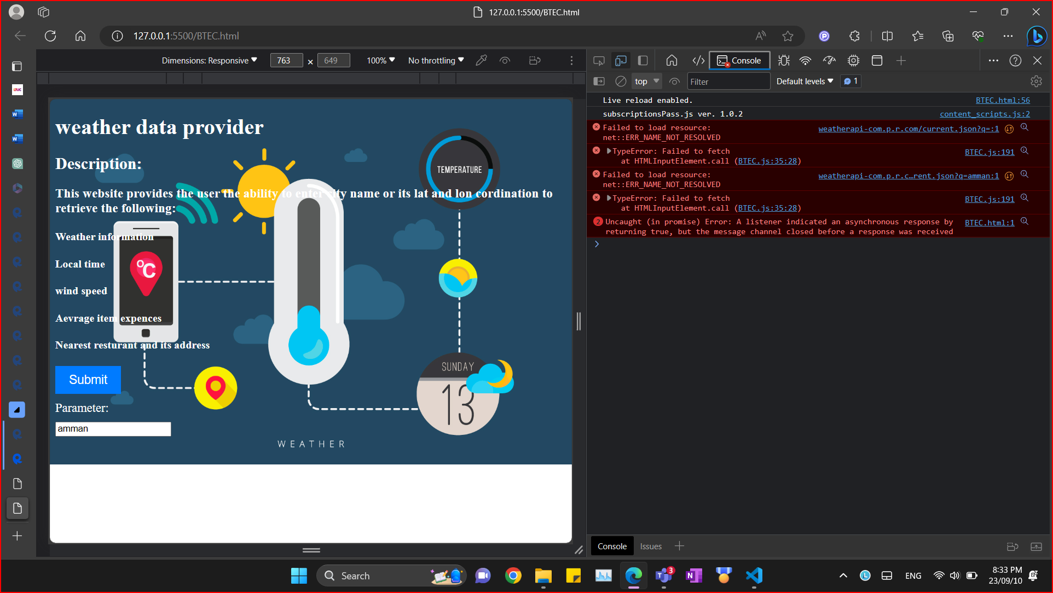

|  |  |  |  |
| --- | --- | --- | --- |
| Test case | Expected output | Actual output | Pass? |
| Do a regular call to the API with all headers and options are correct | View the right result on the HTML page | As expected | Yes ✔ |
| Do fetch call and make a mistake in the API access key so the catch block get executed | Error is printed to the console of your browser | As expected | Yes ✔ |

|  |  |  |  |
| --- | --- | --- | --- |
| Test case | Expected output | Actual output | Pass? |
| A value that make the if block true | Handle the empty field and show a message to fill it | Showing a message to handle empty field | YES |
| A value that make the if block false | If the field is full the application will run normally | Application runs normally | YES |

**2)**

**Blac box testing:**

|  |  |  |  |
| --- | --- | --- | --- |
| Test case | Expected output | Actual output | Pass? |
| Empty field | Message that says fill field | Nothing(console error) | No (Fix) |
| Garbage value | Message that says the parameter that you entered is not available or we couldn’t find the city that you are looking for | Nothing(just a console error) | No (Fix) |
| Random number instead of actual lat and lon values | Throw invalid coordination | Nothing | NO (Solve it) |

**3)**

**Here I handled the empty field problem, if the field is empty when we click on the submit button it will show a message that says fill the field.**

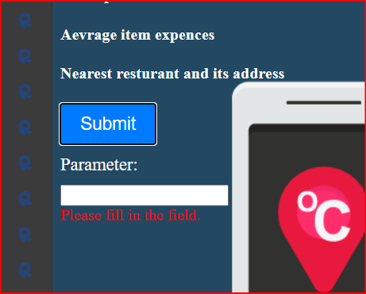

**Here I handled the garbage values that the user may enter and show a message that says Location is not available. And it handles coordination's too, if I were to enter any random coordination value it will show me the same message if the API didn’t find a proper value.**

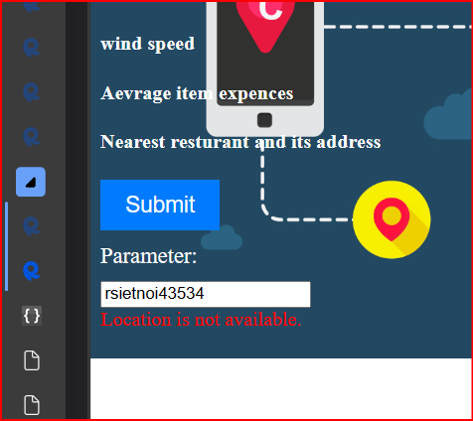

**Plagiarism**

Plagiarism is a particular form of cheating. Plagiarism must be avoided at all costs and students who break the rules, however innocently, may be penalised. It is your responsibility to ensure that you understand correct referencing practices. As a university level student, you are expected to use appropriate references throughout and keep carefully detailed notes of all your sources of materials for material you have used in your work, including any material downloaded from the Internet. Please consult the relevant unit lecturer or your course tutor if you need any further advice.

**Student Declaration**

|  |
| --- |
| **Student declaration**  I certify that the assignment submission is entirely my own work and I fully understand the consequences of plagiarism. I understand that making a false declaration is a form of malpractice.  Student signature: Abdelrahman Saleh Date: |